REPORT 2021-22
Details of campus placement during the year:
Name of the company | No. of students participated | Industry | No. of students selected
Nation with Namo | 21 | Consulting | 2
ZS Associates | 45 | Consulting | 2
Accenture | 69 | Consulting | 3
Jitin Chawla’s Center for Career Development | 9 | Education | 1
TresVista | 13 | Analytics | 6
Headout | 15 | Misc | 1
Studyroom.live | 23 | Education | 2
TopHire | 23 | Misc | 2
Graveiens | 7 | Education | 1
D.E. Shaw | 80 | Financial Services | 1
ICICI Bank | 43 | Financial Services | 4
Gartner | 31 | Analytics | 3
Educational Initiatives | 30 | Education | 2
Godrej | 26 | Misc | 1
Amazon | 78 | Analytics | 4
WIPRO | 9 | Misc | 2
Tech M(paid internship+PPO) | 10 | Misc | 2
Barclays | 71 | Financial Services | 8
MindHouse | 13 | Analytics | 1
PCS Infinity | 2 | Misc | 1
Rippling | 34 | Misc | 1
Skuad | 18 | Analytics | 2
Internships:
Name of the company | No. of students selected
Du Connect | 3
The Tarzan Way | 3
Reading Right | 1
RSVI | 2
Travelyara | 2
Uolo Edtech Pvt. Ltd. | 1
Sarkari School | 6
Super 77 | 12
Edurite | 5
Beyond Meds Foundation | 1
Aashman Foundation | 1
PeaceX | 3
Mission ED | 1
Techwitty services | 9
Cyber Media | 2
Nanhi Kashtiya | 4
Girl Up Rooh | 3
KalpGuru | 3
Preponline | 1
White Hat Jr | 6
Takshashila Consulting | 6
The Forbidden Fruit | 1
Trainident | 2
CRY | 4
Incubr Tech Pvt Ltd | 1
IJNGP | 5
Daurcom | 4
Scaler Academy | 1
The Mystico | 1
Travelyara | 1
Kalp Guru | 3
Holmes & Watson Technology | 3
Social Parindee | 1
Youthfamilybollywood | 1
Coding Jr | 2
Acelot | 1
HumBee | 1
Mr. Moustache's Cake | 1
Goindependent | 1
Hello Study Global | 3
Youth India E- School | 6
SocioSift | 1
GlobalCert Pte. Ltd | 5
Metvy | 2
Inventiva | 3
Trivayu | 1
YTech Raj LLP | 3
Team Soch | 4
Book Your Guru | 1
ChatterPe | 1
Refract Consulting | 10
GoHappyClub | 4
Lean Green | 1
Vasukam | 1
Nut n Pro | 1
Eloquent Oratory Club | 1
FlipItNews | 3
Hello study global | 2
Tutree | 1
Daijar Gurukul | 1
Crack-ED | 1
Logyify | 1
Project Ukiyo | 1
Gau organics | 1
Go Dutch | 3
KalpGuru | 2
ILP Overseas | 2
InvestDoc | 2
VRECA | 1
Swachhta Jagran Samiti | 2
Eventic Banda | 6
Live for Cause | 3
FETE FOUNDATION | 2
Graveiens | 1
Digituala | 1
DU Connect | 1
Travel Yara | 1
EGIYOK | 2
Kalp Guru | 4
Talerang | 1
ULEAD | 3
Swachhta Jagran Samiti | 9
SK Children Foundation | 2
SAIR NETWORK | 7
M&A Network | 2
Finoability | 4
Mass Foundation | 1
IMS | 3
Artsome | 1
Nikore Associates | 1
THB | 1
Unnati | 13
EDJUSTICE FOUNDATION | 2
Arc Tech Labs Pvt. Ltd | 3
Nikore Associates | 1
Mr Moustache's Cakes | 1

Details of the events and initiatives by MHPC during the session:
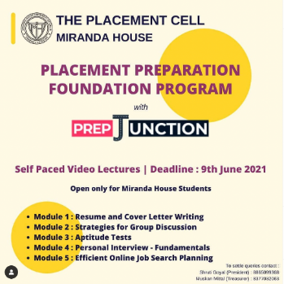
- Placement Preparation Foundation Program, 9 June 2021- The Placement Cell in collaboration with PrepJunction, brought self-paced video lectures on various aspects of preparing for placements such as cover letter writing, personal interviews and much more.
- Succeed at HR Interviews, 16 June 2021- The session gave insights about various processes involved in an interview like Group Discussions, Resume making and Personal Interviews in a detailed and structured manner. It was followed by an in-depth analysis to guide students about the interview procedure.

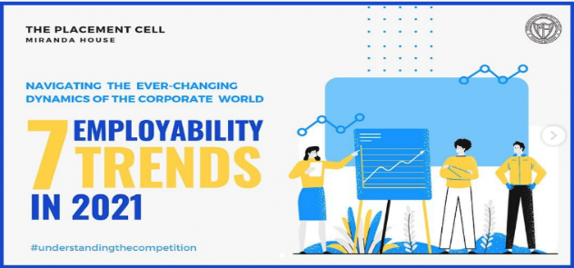
- Blog on 'Employability trends in 2021, 17 June 2021- The blog dealt with seven major job trends in 2021 and how to best navigate them in the pandemic which has changed everybody's work life besides accelerating and even bringing about new trends.

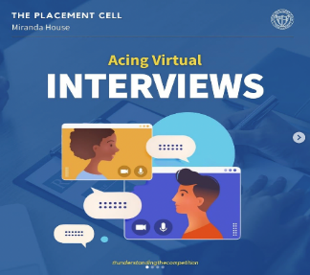
- Infographic on 'Acing virtual Interviews', 22 June 2021- The infographic shared tips for acing online interviews and equipped students with the best knowledge to adapt to the 'new normal.'

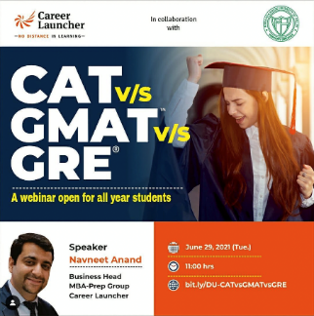
- Webinar on CAT vs GMAT vs GRE, 29 June 2021- The session provided a detailed analysis of each entrance examination along with tips and guidance to crack these entrances. The webinar proved to be highly successful with more than 100 participants.

- Webinar on ‘How to build X Factor to get into Ivy League Colleges, 9 July 2021- The session emphasised the importance of having global exposure in today's world. Studying abroad allows students to experience world culture along with studying from the best educators. It was an extremely insightful session.

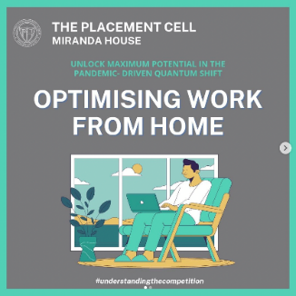
- Blog on 'Optimising work from home', 14 July 2021 - We published a blog on 'Optimising Work From Home' which provided tips to level up Work from Home productivity and maintain a work-life balance simultaneously.

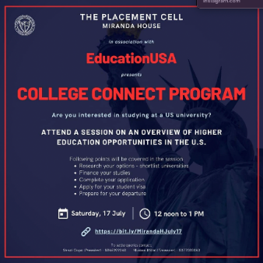
- Webinar on ’An Overview of Higher Education Opportunities in the U.S., 17 July 2021-The session entailed a detailed discussion about the USA and studying prospects in the country. It highlighted important steps to keep in mind while preparing for education in the states. It was a fruitful and illuminating session.

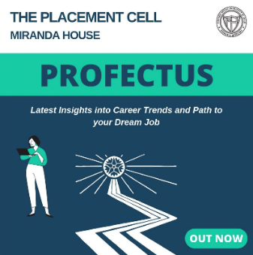
- Profectus (1st edition), 31 July 2021- We launched the first issue of Placement Cell's E-Newsletter, Profectus with an exclusive interview with Ms. Renu Sud Karnad. Our vision for the newsletter was to guide students to comprehend the industry requirements and different career choices available to them.

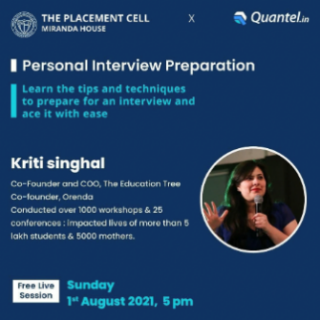
- Webinar on Personal Interview Preparation, 1 August 2021: The co-founder and COO, The Education Tree and The Co-founder, Orenda 135 Quantel The session threw light on the importance of being diplomatic, confident and being yourself during an interview. It emphasised on aligning your strengths to the needs of the organisation. The webinar ended with a Q&A session and proved to be a huge success.

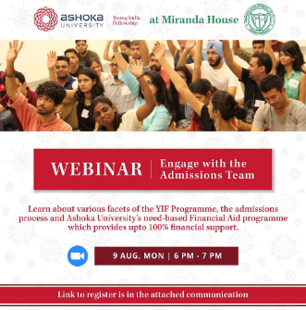
- Webinar on ’Engaging with the Outreach and Admissions Team and learning about the programme', 9 August 2021- The session threw light upon the one year long fellowship offered by Ashoka University. The speaker provided insights about how the fellowship empowers all fellows to reach their full potential in their chosen fields.

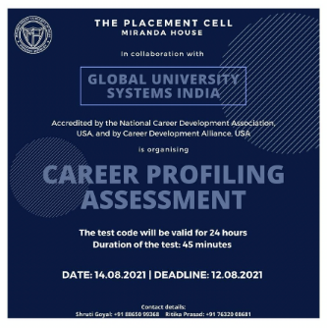
- Career Profiling Assessment Global University System,14 August 2021- The Placement Cell collaborated with Global University System to bring 'Career Profiling Assessment' which was designed by industry experts to help students to identify their strengths and weaknesses through detailed personalised Individual reports.

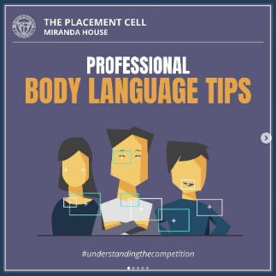
- Infographic on ' Professional Body Language Tips' The infographic on 'Professional Body Language Tips', 16 August 2021- shared essential tips on professional body language which should always be kept in mind since it's one of the most important forms of non verbal communication

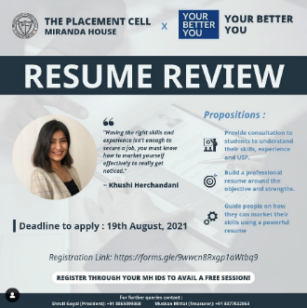
- Resume review session, 19 August 2021- ​​The resume review session provided an unique opportunity to students to understand their skills, experiences and build a professional resume around their objectives and targets to market themselves and reach their goals.

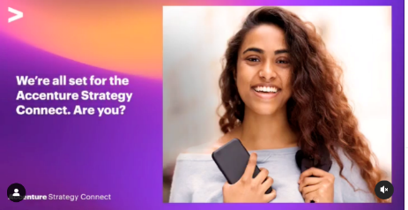
- Accenture Strategy Connect, Signals of Change, 19th August, 2021 - 21st August, 2021: virtual strategy and consulting three-day symposium 80+ Accenture The Accenture Strategy Connect was a three-day symposium designed to gain valuable business strategy wisdom through competitive challenges, problem identification, solution-finding and gamification.

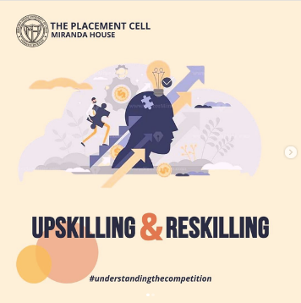
- Blog on 'Upskilling and Reskilling' - 25 August 2021- The blog on 'Upskilling and Reskilling’ suggested ways to stay relevant in the industry and coping up with the ever-changing market needs by learning, acquiring and perfecting new skills.

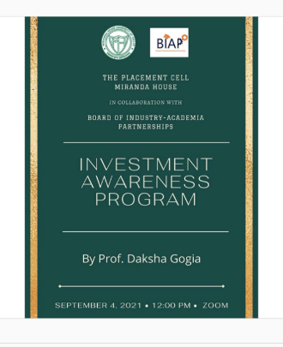
- Investment Awareness Program - 4 September 2021- Dr. Navin Punjabi 68 Board of Industry Academia Partnerships The session highlighted some basic concepts of the financial world like Joint Account, SIPs, Stock Markets, and how to access them. It was aimed at spreading awareness about the do's and don'ts in the securities market and Investment protection measures.

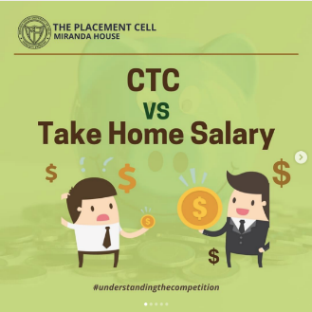
- Infographic on 'Take home salary vs CTC' - 17 September 2021- We published an infographic on 'Take home salary vs. CTC' which critically and accurately analysed the nitty-gritties of CTC and Take Home Salary to help one negotiate a good package.

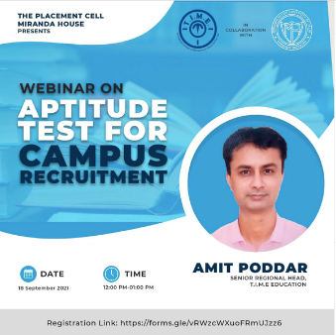
- Webinar on ‘Aptitude test for campus Recruitment’ - 18 September 2021- Mr. Amit Poddar (MBA from Indian Institute of Planning and Management, the Senior regional head at T.I.M.E education.

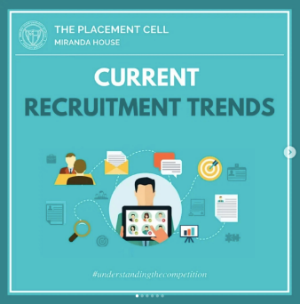
- Infographic on Current Recruitment Trends - 29 September 2021- The infographic on 'Current Recruitment Trends' threw light on the latest talent acquisition and recruitment trends to aid students to understand the evolving nature of hiring practices and meet the demand accordingly.

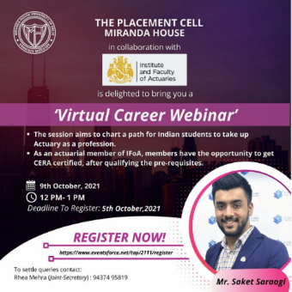
- Virtual Career Webinar - 9 October 2021 - This Virtual Career Webinar charted the path for Indian students to take up Actuary as a profession and the opportunities and benefits they would reap after qualifying the requisites.

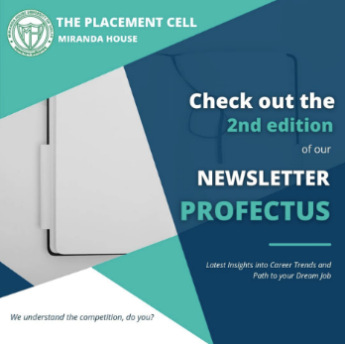
- Profectus(Newsletter) 2nd Edition - 24 November, 2021 - The Cell released the Second edition of our e-newsletter- “Profectus” which aimed at enabling the readers to comprehend the industry requirements, with interviews and articles to “understand the competition.”

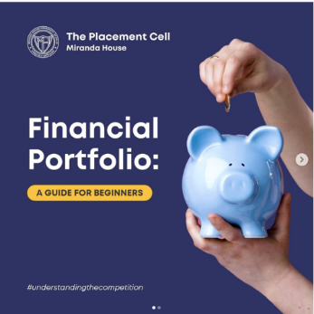
- Blog on 'Financial Portfolio: A guide for beginners' - 26 December, 2021- he blog on 'Financial Portfolio:A guide for beginners' provided students an elementary understanding of Financial portfolio, the benefits of investing at an early age and the techniques to make sound financial decisions.

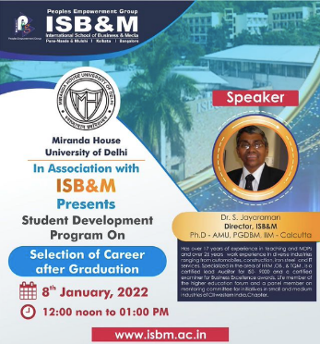
- Webinar on ‘Selection of career after graduation - 8 January, 2022 - The webinar focused on the ever-changing career options, top foundational skills required to sustain and ways to cope with career related challenges.

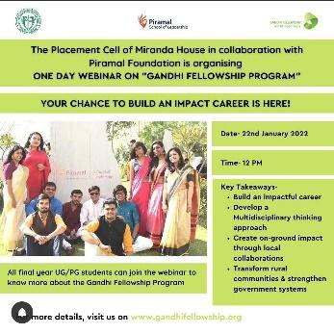
- Webinar on gandhi fellowship programme - 22nd January, 2022
Gandhi Fellowship Program is a full-time, transformational youth leadership program designed for young individuals to develop a multidisciplinary thinking approach. The session talked about the opportunity that one gets through this program to learn about the grassroots challenges that people in rural areas face and to experiment with different solutions to solve their problems.

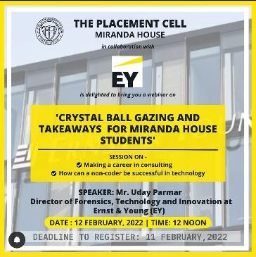
- Crystal Ball Gazing and Takeaways for Miranda House Students 11th February, 2022
Placement Cell in collaboration with 'EY' conducted a session wherein topics like right internships, personal branding, and the correct approach towards one's goals were discussed. The speaker Mr. Uday Parmar talked about the right time for entrepreneurship, the need for finding the right mentor, and the need to develop unique skills in one’s interested field.

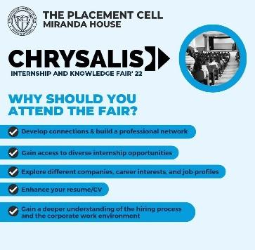
- Chrysalis - 2nd- 3rd March, 2022
On 2nd & 3rd March, placement cell organised its annual Internship & knowledge fair 'Chrysalis'. Over 30 firms participated in the fair, giving internship stipends as high as 20,000 and 8 LPA CTC for job roles to 500+ students. Mr. Arman Sood (founder, Sleepy owl coffee) and Mr. Tushar Mehta (Director- Client Engagements at D2C) were invited as the event's chief guests who shared their experiences and motivated the students.

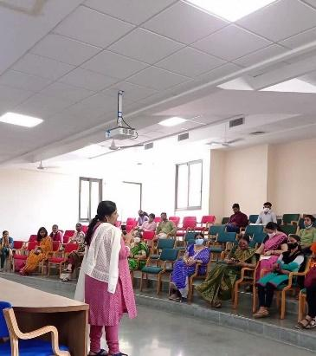
- Skill Hub Centre PMKVY
Placement Cell in collaboration with National Skill Development Corporation (N.S.D.C.) and PMKVY (Pradhan Mantri Kaushal Vikas Yojana) established Miranda House Skill Hub Centre which aims to bring about skill enhancement through 100% free government certified courses.

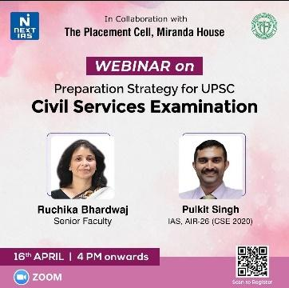
- Quiz competition with next IAS- 16th April, 2022
This webinar was extremely fruitful for the civil services aspirants. The speaker Ms. Bharadwaj alongside Mr. Pulkit (AIR 26) gave insights into the process of the examination, strategies, study material, tips & tricks for the interview round and a lot more.

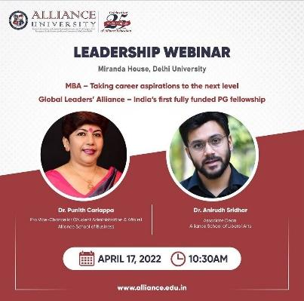
- Leadership webinar with Alliance University- 17th April, 2022
The session focused on the importance of postgraduate studies, especially management programs like MBA. the speaker highlighted various job prospects available for students along with improving their entrepreneurial abilities. It was an extremely insightful session.

